**Балтийский государственный технический университет**

**«ВОЕНМЕХ» им. Д.Ф. Устинова**

**Кафедра И9**

**«Информационные системы и компьютерные технологии»**

**Лабораторная № 6**

**Вариант 7**

**По дисциплине: «МАТ.СТАТИСТИКА И СП** **»**

**Выполнил:**

Студент Кузнецов С.Н.

Группа И322

**Преподаватель:**

Брацлавский А.А.

Санкт-Петербург

2015

**Исходные значения:** 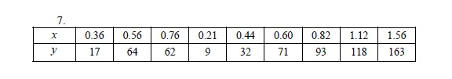

**Simple Regression - Y vs. X**

Dependent variable: Y

Independent variable: X

Linear model: Y = a + b*X

**Coefficients**

|  |  |  |  |  |
| --- | --- | --- | --- | --- |
|  | *Least Squares* | *Standard* | *T* |  |
| *Parameter* | *Estimate* | *Error* | *Statistic* | *P-Value* |
| Intercept | -13,1424 | 7,63139 | -1,72215 | 0,1287 |
| Slope | 116,218 | 9,36299 | 12,4125 | 0,0000 |

**Analysis of Variance**

|  |  |  |  |  |  |
| --- | --- | --- | --- | --- | --- |
| *Source* | *Sum of Squares* | *Df* | *Mean Square* | *F-Ratio* | *P-Value* |
| Model | 18707,0 | 1 | 18707,0 | 154,07 | 0,0000 |
| Residual | 849,931 | 7 | 121,419 |  |  |
| Total (Corr.) | 19556,9 | 8 |  |  |  |

Correlation Coefficient = 0,978029

R-squared = 95,6541 percent

R-squared (adjusted for d.f.) = 95,0332 percent

Standard Error of Est. = 11,019

Mean absolute error = 8,50975

Durbin-Watson statistic = 2,23411 (P=0,5115)

Lag 1 residual autocorrelation = -0,213179

**The StatAdvisor**

The output shows the results of fitting a linear model to describe the relationship between Y and X. The equation of the fitted model is

Y = -13,1424 + 116,218*X

**Analysis of Variance with Lack-of-Fit**

|  |  |  |  |  |  |
| --- | --- | --- | --- | --- | --- |
| *Source* | *Sum of Squares* | *Df* | *Mean Square* | *F-Ratio* | *P-Value* |
| Model | 18707,0 | 1 | 18707,0 | 154,07 | 0,0000 |
| Residual | 849,931 | 7 | 121,419 |  |  |
| Lack-of-Fit | 849,931 | 7 | 121,419 |  |  |
| Pure Error | 0 | 0 |  |  |  |
| Total (Corr.) | 19556,9 | 8 |  |  |  |

**Predicted Values**

|  |  |  |  |  |  |
| --- | --- | --- | --- | --- | --- |
|  |  | *95,00%* |  | *95,00%* |  |
|  | *Predicted* | *Prediction* | *Limits* | *Confidence* | *Limits* |
| *X* | *Y* | *Lower* | *Upper* | *Lower* | *Upper* |
| 0,21 | 11,2634 | -18,3859 | 40,9126 | -2,88467 | 25,4114 |
| 1,56 | 168,158 | 134,919 | 201,396 | 147,52 | 188,795 |

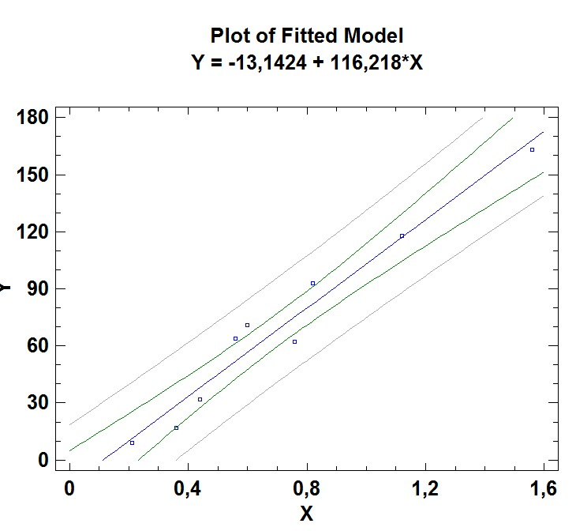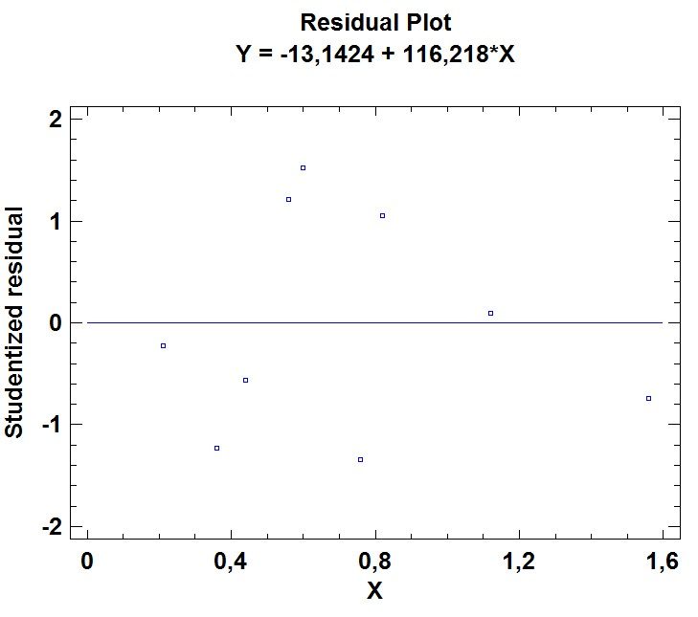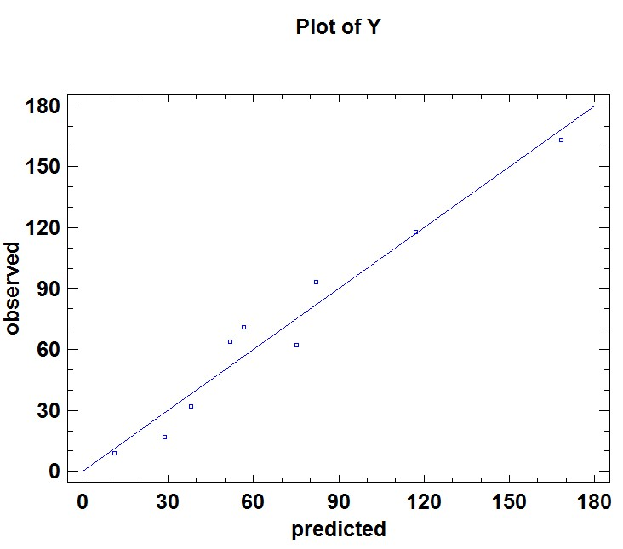

**Comparison of Alternative Models**

|  |  |  |
| --- | --- | --- |
| *Model* | *Correlation* | *R-Squared* |
| Double squared | 0,9901 | 98,03% |
| Square root-X | 0,9783 | 95,71% |
| Linear | 0,9780 | 95,65% |
| Square root-Y logarithmic-X | 0,9759 | 95,24% |
| Double square root | 0,9705 | 94,18% |
| Squared-Y | 0,9689 | 93,88% |
| Multiplicative | 0,9657 | 93,26% |
| S-curve model | -0,9605 | 92,25% |
| Logarithmic-X | 0,9524 | 90,71% |
| Square root-Y | 0,9415 | 88,63% |
| Squared-X | 0,9328 | 87,02% |
| Squared-Y square root-X | 0,9278 | 86,09% |
| Logarithmic-Y square root-X | 0,9266 | 85,86% |
| Square root-Y reciprocal-X | -0,9067 | 82,20% |
| Reciprocal-Y logarithmic-X | -0,8718 | 76,01% |
| Exponential | 0,8689 | 75,49% |
| Squared-Y logarithmic-X | 0,8605 | 74,05% |
| Square root-Y squared-X | 0,8552 | 73,13% |
| Reciprocal-X | -0,8295 | 68,80% |
| Logarithmic-Y squared-X | 0,7454 | 55,56% |
| Squared-Y reciprocal-X | -0,6772 | 45,86% |
| Reciprocal-Y squared-X | -0,5289 | 27,98% |
| Reciprocal-Y | <no fit> |  |
| Reciprocal-Y square root-X | <no fit> |  |
| Double reciprocal | <no fit> |  |
| Logistic | <no fit> |  |
| Log probit | <no fit> |  |
|  |  |  |
|  |  |  |

**Influential Points**

|  |  |  |  |  |  |
| --- | --- | --- | --- | --- | --- |
|  |  |  | *Predicted* | *Studentized* |  |
| *Row* | *X* | *Y* | *Y* | *Residual* | *Leverage* |

Average leverage of single data point = 0,222222

**Unusual Residuals**

|  |  |  |  |  |  |
| --- | --- | --- | --- | --- | --- |
|  |  |  | *Predicted* |  | *Studentized* |
| *Row* | *X* | *Y* | *Y* | *Residual* | *Residual* |

**The StatAdvisor**

The table of unusual residuals lists all observations which have Studentized residuals greater than 2 in absolute value. Studentized residuals measure how many standard deviations each observed value of Y deviates from a model fitted using all of the data except that observation. In this case, there are no Studentized residuals greater than 2.